NCACCIA/SDAA Joint Conference

Spring 2018 – March 19-20
Dewitt E. Rhoades Conference Center

March 19, 2018
8:00-9:00 a.m. | Registration & Continental Breakfast | Conference Center
9:00-9:20 a.m. | Opening Remarks & Door Prizes  Dr. Silvia-Patricia Husain, Vice President for Student Affairs & Enrollment Management, Gaston College  Dr. Michael Quillen, Vice President, Division of Academic Affairs, Rowan-Cabarrus Community College  Welcome  Dr. Gary M. Green, President, Forsyth Technical Community College | Conference Center
9:20-10:45 a.m. | Opening Keynote: Rethinking the Student Experience: From Application to Graduation  Dr. Leonard Bass, Dean of Learning Support, Valencia College | Conference Center
10:45-11:00 a.m. | Break Sponsored by Cengage
11:00-12:00 p.m.  Breakout Sessions #1 | Helping Students Enter a Pathway:  The Pathway Puzzle: Processes and Practices for Student Success?  Scott Byington, Dean of Arts, Sciences, & Advising, Central Carolina Community College | Rhoades A
 | Clarify Paths to Student End Goals:  Life is a Highway: Pathways to Success at Stanly Community College  Dr. Heather Hill, Vice President of Academic Affairs, Stanly Community College  Dr. Myra Furr, Vice President of Student Success/Dean of Students, Stanly Community College | Rhoades B
 | Keeping Students on Pathway:  Beyond the Court: Success Strategies for Student-Athletes  Jeffrey Allen, Dean of Enrollment & Outreach, Vance-Granville Community College  Jermiel Hargrove, Coordinator of Student Activities and Athletics | Rhoades C
12:00-1:00 p.m. | Lunch Sponsored by Aviso | Conference Center

1:00-2:00 p.m.  Breakout Sessions #2 | Helping Students Enter a Pathway:  Enrollment Matters: Residency Determination Services  Sabrina Terry, Dean of Student Services, Surry Community College (Moderator)  Louanna O. Castleman, Director of Admissions & Counseling, Fayetteville Technical Community College  Jean Groome, Director of Admissions, Forsyth Technical Community College  Shannon Hall, Student Enrollment Technician, Davidson County Community College  Nathaniel Stout, Admissions Specialist, Craven Community College | Rhoades A
 | Keeping Students on Pathway:  Return on Investment: Success Coaching as a Cost-Effective Intervention  Derrick Dupuis, Institutional Research Analyst, Central Carolina Community College | Rhoades B
 | Ensuring Student Learning:  Pathways to Equity in Student Learning Outcomes  Dr. Roxanne Newton, Executive Director, NC Student Success Center, System Office | Rhoades C
2:00-2:15 p.m. | Break
2:15-3:15 p.m.  Breakout Sessions #3 | Ensuring Student Learning:  Pedagogy Matters: An Instructional Framework for College Instructors  Dr. Trent Mohrbutter, Vice President of Instruction & Chief Academic Officer, Nash Community College | Rhoades A
 | Keeping Students on Pathway:  It All Begins with a SPARC3  Dr. Heather Woodson, Dean of Arts & Sciences, Gaston College | Rhoades B
 | Clarify Paths to Student End Goals:  Wayne Community College - Clearing a Pathway to Success  Dr. Gene Smith, Vice President of Academic Affairs & Student Services, Wayne Community College | Rhoades C
3:15-3:30 p.m. | Break
3:30-4:30 p.m.  Breakout Sessions #4 | Keeping Students on Pathway:  Round Table - Grievance Procedures  Dr. James W. Kelley, Associate Vice President-Student Services, North Carolina Community College System | Rhoades A
 | Clarify Paths to End Goals:  NCCCS Advising and Student Support Framework  Dr. Daniel Alvarado, Associate Director, Student Support, North Carolina Community College System  Dr. Roxanne Newton, Executive Director, NC Student Success Center, North Carolina Community College System | Rhoades B&C
5:00 – 7:00 p.m. | Networking Reception | Conference Center Lobby

March 20, 2018
8:00-9:00 a.m. | Breakfast Buffet |  |  | Conference Center
9:00-10:30 a.m. | Closing Keynote: What We Learned and How It Impacted Persistence  Dr. Leonard Bass, Dean of Learning Support, Valencia College |  |  | Conference Center
10:30-10:45 a.m. | Break |  |  | Conference Center
10:45-11:45 a.m. | Open Educational Resources (OER) and Ebooks - Challenges and Benefits to Free and Low-cost Course Content Panel Discussion  Cherise Millsaps, Reading and English Instructor, Surry Community College  Dr. Gene Smith, Vice President of Academic and Student Services, Wayne Community College  Dr. Jami Woods, Vice President, Academic Affairs, Surry Community College |  |  | Rhoades A
 | Establishing an Apprenticeship Program  Suzanne Rohrbaugh, Vice President, Academic Affairs, Randolph Community College  Melinda Eudy, Dean of Curriculum Programs, Randolph Community College |  |  | Rhoades  B & C
11:45-12:45 p.m. | Lunch Buffet |  |  | Conference Center
12:45-1:45 p.m. | SACS Discussion Panel: SACSCOC Updates, Ongoing Compliance and QEP Best Practices  Dr. Deborah Grimes, Senior Vice President of Instruction and Student Services  Dr. Tracie Ivey, Vice President for Institutional Effectiveness and Innovation, Wayne Community College  Dr. Gene Smith, Vice President of Academic and Student Services, Wayne Community College  Connie Wolfe, Dean of Arts & Sciences, Surry Community College |  |  | Rhoades A
 | CCRG & RISE  Susan Barbitta, Education Program Consultant, North Carolina Community College System |  |  | Rhoades B&C
1:45-2:45 p.m. | System Office Updates  Dr. Lisa Chapman, Senior Vice President/Chief Academic Officer, North Carolina Community College System |  |  | Conference Center
2:45-3:00 p.m. | Closing Remarks & Door Prizes |  |  | Conference Center
Sponsors for the 2018 Joint Administrators Conference:
 |  | 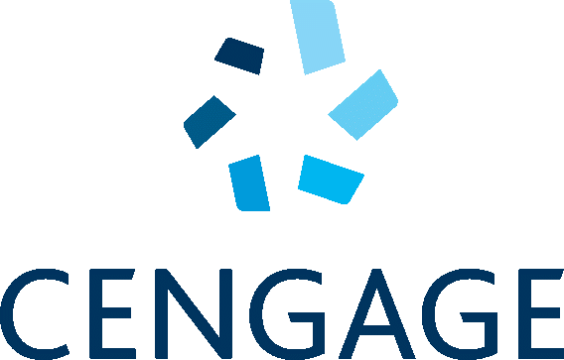 | 