**My Education Plan Assignment - AA Degree Seeking**

Name: Alyssa Costales

The purpose of the My Education Plan assignment is to allow students to gain an understanding of:

* The usefulness of My Education Plan in LifeMap
* The pros and cons of specific institutions and programs that a student is considering for transfer
* The cost of tuition and the requirements for admission to the transfer institution
* The courses necessary for a student to complete an AA degree and be prepared for transfer to another institution
* The amount of time required for completion of an AA degree

**Instructions: Complete all four parts from this handout in order to earn full credit for the My Education Plan assignment. You will need to upload your degree program sheet, your MEP “Look Ahead” Checklist (from Part 3) and this document to Blackboard. This document must be typed. Remember to upload all three items in Blackboard before clicking “submit.”**

**Part 1: What is my degree and what is my catalog year?**

Follow the steps in accessing your My Education Plan (MEP) Checklist.   After complete the MEP Checklist, answer the corresponding questions at the end.

**How to access your My Education Plan Checklist in ATLAS**

1. Login to ATLAS and click on the **My LifeMap** tab.
2. Click **My Education Plan** (see image below).



1. Review the My Education Plan Checklist that populates. This is an overview of your declared degree. The MEP Checklist will display all of the courses that are necessary for your degree and the courses that you have already completed. Sections that say, “Still Needed” indicate that you are missing course(s) in that area to complete your program. The MEP Checklist will also display all of the courses that will fulfill that area requirement.
2. Take special note of your catalog year, which should be displayed in the third red row (see image below). Knowing your catalog year is very important as some catalog years have different course requirements.

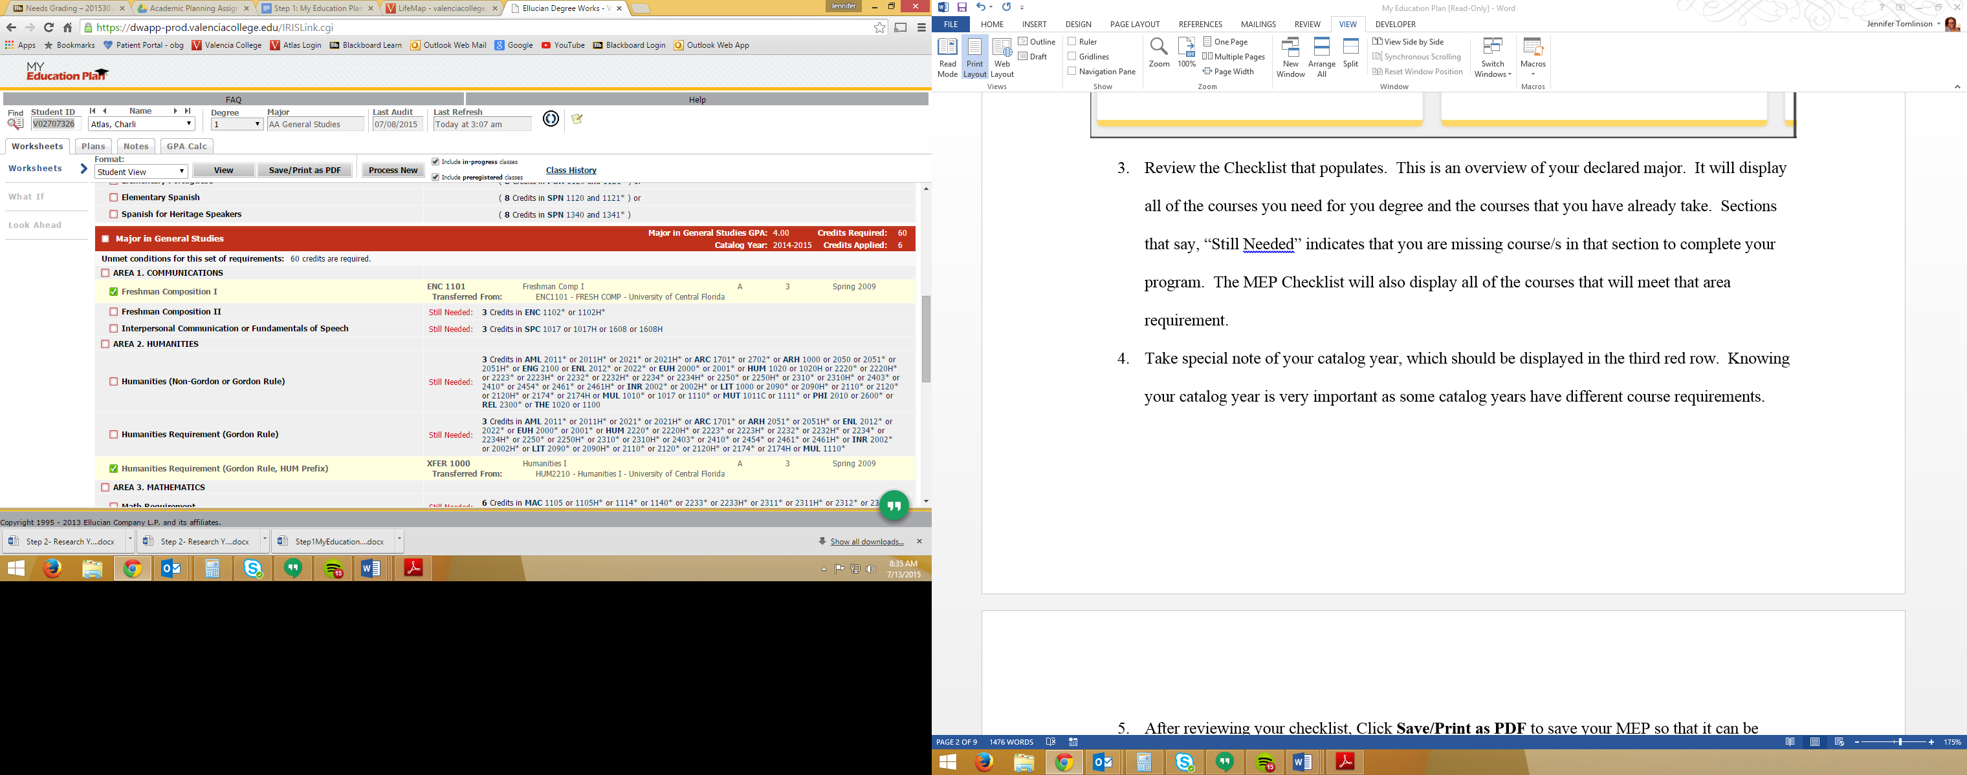

After reviewing your MEP Checklist, answer the following questions:

1. **What degree is listed in your MEP Checklist? Dual-Enrollment**
2. **What is your catalog year? Fall 2015**
3. **Do you need to change your major? yes**



**Before you proceed…**

If your catalog year does not say 2015-16, or if you plan to change your major, you need to meet with an Academic Advisor. Please do so as soon as possible as there may be differences in your degree requirements.

If you need additional help navigating the entire My Education Plan tool in ATLAS use the links below to access helpful videos.

MEP “Checklist” <http://youtu.be/C6Tm9CDuO2E>

MEP “What If” <http://youtu.be/n_y4HN7GeJ4>

MEP “GPA Calculator” <http://youtu.be/163a99LCZ9U>

**Part 2: Where am I going?**

Complete the form below about two institutions you are interested in attending. You can determine institutions that would be a good match for your degree or other “wants” on the College Navigator website (<http://nces.ed.gov/collegenavigator/>).

Respond to the series of questions about the two institutions in the space provided using complete sentences. Each question must have a detailed response; using “none” or “N/A” as a response is not sufficient. Consider what is most important to you, the pros and cons of an institution, and what you want for your future. You should reference your institution’s website or College Navigator to obtain information to assist with your responses.

Be sure to check off which institution has the advantage for each category; use your responses and the advantage check-marks to determine which institution is currently your future transfer school.

|  |  |  |  |  |
| --- | --- | --- | --- | --- |
|  | **College Choice #1:University of South Florida** | **Advantage** | | **College Choice #2:University of West Florida** |
| **Location:**   1. Where is the school located? (city, state; is it urban or rural) 2. What are your plans to get from home to school your first term? | 1. Tampa, Florida ; urban 2. Live on campus and walk |  |  | 1. Pensacola, Florida ; suburban 2. live on campus and walk |
|  |  | **Advantage** | |  |
| **Program/Major:**   1. What program or major would you pursue? 2. What unique opportunities are provided for students in your program or major? (use the school’s website to research –organizations, honor societies, study abroad, internships) | 1. psychology 2. they have an honors program, research opportunities |  |  | 1. Psychology 2. hands on experience |
| **Tuition/Cost:**   1. What is the cost of one year’s tuition? (find the cost with College Navigator) 2. Calculate the overall tuition cost for your degree. (answer from a. X number of years) 3. What other expenses would you incur at this school (room and board, transportation)? | 1. 6,461 2. 12,922 3. dorm, books |  |  | 1. 6,444 2. 12,888 3. dorm, and books |
|  |  | **Advantage** | |  |
| **Environment/Campus Setting:**   1. Describe the size and setting of the campus. 2. Evaluate if the school has the conveniences and necessities you want (ex: social and recreational activities, weather, child care, etc.) | 1. Urban setting, big campus 2. It does |  |  | 1. suburban, smaller campus 2. It does |
| **Student Population:**  Use College Navigator to answer these questions.   1. Discuss the student population and demographic and how it will encourage your personal development and college success. 2. What is the student to faculty ratio? 3. What is your comfort level with the student population and student to faculty ratio? | 1. 41,938 2. 25 to 1 3. I feel that my comfort level doesn’t change much, it is not a bad ratio |  |  | 1. 12,602 2. 23 to 1 3. I feel that my comfort level doesn’t change much, it is not a bad ratio |

**Final Decision:**

Based on your research of the two institutions and your analytical responses to the questions, explain why you selected a particular school and why you gave it the advantage in those categories. Your one paragraph response should be in complete sentences and include specific facts that demonstrate you have thought critically about the institution you have selected.

I have chosen these schools because of where they are. They are in Florida so I would not have to pay out of state tuition which is more expensive than out of state tuition. These schools also are not local to Winter Park which I want to leave once I get into college, but they are within a few hours of a road trip back and forth. I feel like these schools have beneficial programs for what I am looking to major in. USF has an honors program and the research opportunities. Then UWF has hands on experience. Depending on which college I choose to go to those both would help me greatly.

**Part 3: What do I need?**

1. Locate your degree program sheet. To obtain your degree program sheet, go to your institution’s undergraduate catalog or <https://www.flvc.org/>. Download the program sheet as a PDF file and upload the program sheet with this document in Blackboard.
2. Review the courses required for your degree to help you select classes for the following terms.
3. After you have selected the classes that you plan to take at Valencia, you may create your My Education Plan. You must submit a copy of your My Education Plan for final grading in Blackboard.

# How to create your My Education Plan in Atlas

1. Login to Atlas and click on the **My LifeMap** tab.
2. Click **My Education Plan**.

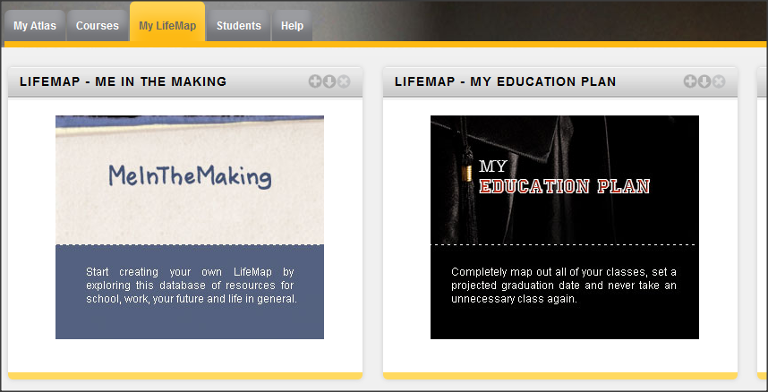

1. Click **What If** in the left column.
2. For the Catalog Year, click the drop down arrow and select **2015-2016**.
3. In the Choose Your Different Areas of Study section, click the drop down arrow to select your **Major**. If you do not see your major listed, select **General Studies (AA)**.
4. In the Choose Your Future Classes section, enter the classes that you need to take at Valencia College. Enter the **Subject** (example: SLS), then the **Number** (example: 1122), then click **Add Course**. Repeat this step until all classes have been entered. If you add an incorrect course, select it from the “Courses you are considering” list and then click Remove Course.
5. Click **Save/Print as PDF** button to view a copy of your My Education Plan.

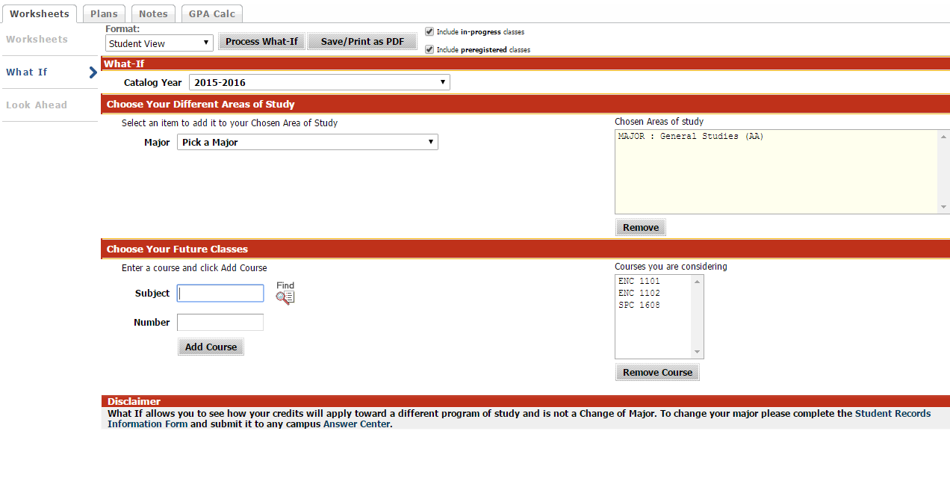

**3**

**4**

**5**

**6**

**7**

If you need additional help saving your What If Worksheet, use the link below:

MEP: "How To Save A Look Ahead MEP"  <http://youtu.be/ZuScge33LnA>

1. Once you have completed the My Education Plan, fill out the Term-By-Term Worksheet below to show when you plan to take your classes.

|  |  |  |  |  |  |  |  |
| --- | --- | --- | --- | --- | --- | --- | --- |
| **Valencia College – Term-By-Term Worksheet** | | | | | | | |
| **Program or Transfer Plan:** Click here to enter text. | | | | | | | |
| TERM: Summer 2016 |  |  | TERM: Fall 2016 |  |  | TERM: Spring 2017 |  |
| Course | Cr. Hrs. |  | Course | Cr. Hrs. |  | Course | Cr. Hrs. |
| MAT 1033C | 3 |  | EUH 2001 | 3 |  | STA 2023 | 3 |
| Click here to enter text. |  |  | PHI 2010 | 3 |  | PHI 2600 | 3 |
| Click here to enter text. |  |  | BSC 1010c | 4 |  | BSC 1026 | 3 |
| Click here to enter text. |  |  | MAC 1105 | 3 |  | Click here to enter text. |  |
| Click here to enter text. |  |  | CLP 2140 | 3 |  | Click here to enter text. |  |
| Total Cr. Hrs. | 3 |  | Total Cr. Hrs. |  |  | Total Cr. Hrs. |  |
|  |  |  |  |  |  |  |  |
| TERM: |  |  | TERM: |  |  | TERM: |  |
| Course | Cr. Hrs. |  | Course | Cr. Hrs. |  | Course | Cr. Hrs. |
| Click here to enter text. |  |  | Click here to enter text. |  |  | Click here to enter text. |  |
| Click here to enter text. |  |  | Click here to enter text. |  |  | Click here to enter text. |  |
| Click here to enter text. |  |  | Click here to enter text. |  |  | Click here to enter text. |  |
| Click here to enter text. |  |  | Click here to enter text. |  |  | Click here to enter text. |  |
| Click here to enter text. |  |  | Click here to enter text. |  |  | Click here to enter text. |  |
| Total Cr. Hrs. |  |  | Total Cr. Hrs. |  |  | Total Cr. Hrs. |  |
|  |  |  |  |  |  |  |  |
| TERM: |  |  | TERM: |  |  | TERM: |  |
| Course | Cr. Hrs. |  | Course | Cr. Hrs. |  | Course | Cr. Hrs. |
| Click here to enter text. |  |  | Click here to enter text. |  |  | Click here to enter text. |  |
| Click here to enter text. |  |  | Click here to enter text. |  |  | Click here to enter text. |  |
| Click here to enter text. |  |  | Click here to enter text. |  |  | Click here to enter text. |  |
| Click here to enter text. |  |  | Click here to enter text. |  |  | Click here to enter text. |  |
| Click here to enter text. |  |  | Click here to enter text. |  |  | Click here to enter text. |  |
| Total Cr. Hrs. |  |  | Total Cr. Hrs. |  |  | Total Cr. Hrs. |  |

**Part 4: What is my Action Plan?**

After reviewing the degree program sheet and the institutions you are considering, write a summary about the institution and program you plan to pursue. This summary should be two paragraphs in length and address the topics outlined below.

Discuss your **action plan** to get accepted into the program of your choosing by referring to your program sheet to find the requirements for admission to your program.  Explain what GPA requirements, application deadlines, foreign language classes and other requirements might need to be fulfilled for admission. Also research if your program requires a portfolio, audition, interview, etc. In your action plan, also be sure to include the **length of time** needed to complete your degree in **terms** at Valencia; also state the **month and year** that you will graduate Valencia.  Determine how long it will take you to graduate to earn your bachelors when you transfer.

Click here to enter text. I hope to get accepted into the psychology transfer program by taking the classes I need to. Those classes are all general education classes, and then electives leaning toward what you are planning to major in, and a foreign language course. There was no specific GPA listed for this program, but I would assume it would be at the lowest a 3.0. I am also not sure if I need a portfolio or audition or anything, although I don’t think I do. The terms I would be taking here would be, my last term, current term, Summer 2016, Fall 2016, Spring 2017, and a few more courses in summer 2017 to finish off at Valencia and then transfer to the college of my choosing. When transferring over I’m guessing I’d have 2 years, possibly a little more till I would have completed my bachelors degree, and then I would be moving on from there.